**Smartphone market analysis**

**Ryan Jabłoński**

**Key takeways and overview**

Apple:

- their devices have high positive price to specs correlation in all categories, which means that customers need to pay more to get the most out of their devices

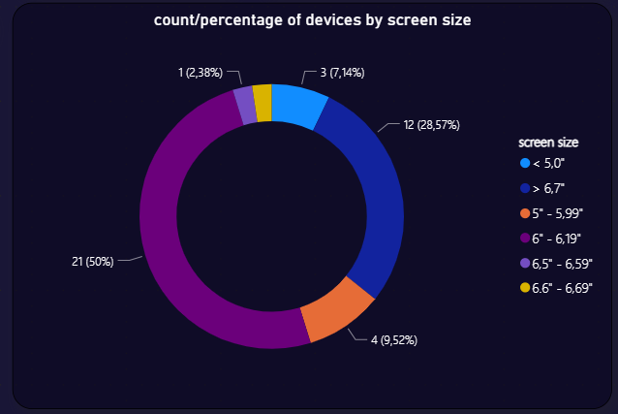

- half of Apple iPhone offerings are around 6,1” in screen size, which is considered a medium size nowadays

- iPhone devices hit the premium price segment with an average price of 5190 zł, with their cheapest offering being around ~2000 zł

Samsung:

- screen size and charging power indicates moderate, positive correlation with price, which means that sometimes customers need to pay more for a bigger screen and faster charging

- high positive correlation around 0,8 on *max. clock speed* and *RAM amount* means that Samsung puts beefier processors, equipped with more RAM more often in their premium lineup

- there is very low, negative correlation between price and battery capacity, which means that pricier Samsung phones might have smaller batteries than their cheaper offerings

Top 10 brands by worldwide market share, [according to GBM](https://www.globalbrandsmagazine.com/top-10-mobile-brands-in-the-world-2023/):

NOTE: report includes Redmi and Poco devices as a part of Xiaomi brand

* there is almost no correlation between charging power, screen refresh rate, battery capacity and the price of these devices - this means that there are lots of cheaper, yet still awesome phones that don’t stick out of pricier competition in terms of fast charging, screen refresh rate and battery life
* statement that more expensive devices have better CPU and more RAM is mostly true
* cheap devices mostly get similar or even bigger sized batteries than more premium phones, that is true since powerful CPUs need more power and often flagship-considered phones don’t provide enough screen-on-time and require to be powered daily

Average price for top selling brands:

Metrics:

a) correlation based on price and different specs - it shows the relationship between two sets of variables

0.9 to 1 (-0.9 to −1)

Very high positive (negative) correlation

0.7 to 0.9 (-0.7 to -0.9)

High positive (negative) correlation

0.5 to 0.7 (-0.5 to -0.7)

Moderate positive (negative) correlation

0.3 to 0.5 (-0.3 to -0.5)

Low positive (negative) correlation

0 to 0.3 (0 to -0.3)

Negligible/no correlation

Price to specs:

- price_pln to fast_charging

- price_pln to refresh_rate

- price_pln to ram

- price_pln to processor_speed

- price_pln to battery_capacity

- price_pln to screen_size

b) count and percentage of devices by screen_size

c) basic price statistics:

- minimum

- maximum

- average

- median

d) distribution of device count according to their price

e) distribution of device count according to brand

Filters:

- filter by brand_name, then by model

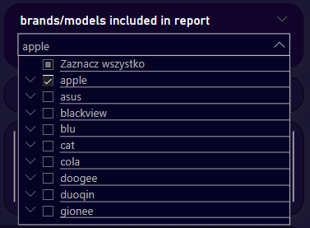

- filter by price

- filter by screen_size

- filter by picking one or more devices from the table view